|  |  |
| --- | --- |
| NAME | Adwait S Purao |
| UID No . | 2021300101 |
| Experiment No. | 6,7,8 |

**AIM :**

|  |
| --- |
| To perform basic arithmetic operations through assembly language program in 8085 |
| To simulate COPY and PASTE operation through 8085 assembly program |
| To write a program to add N elements stored in an array of 8 bit numbers (8085) |

**HARDWARE** : Microprocessor 8085 board

**THEORY:**

**Definition**:

8085 is an **8-bit microprocessor** as it operates on 8 bits at a time and is created with **N-MOS technology**. This [microprocessor](https://electronicsdesk.com/microprocessor.html) exhibits some unique characteristics and this is the reason it still holds popularity among the microprocessors.

Microprocessor Architecture

The **microprocessor** is the CPU (Central Processing Unit) of a computer. It is the heart of the computer. Here, we will describe Intel 8085 as it is one of the most popular 8-bit microprocessor.

## **ALU**

The **Arithmetic and Logic Unit**, ALU performs the arithmetic and logical operations:

* Addition
* Subtraction
* Logical AND
* Logical OR
* Logical EXCLUSIVE OR
* Complement (Logical NOT)
* Increment (add 1)
* Decrement (subtract 1)
* Left shift, Rotate left, Rotate right
* Clear, etc.

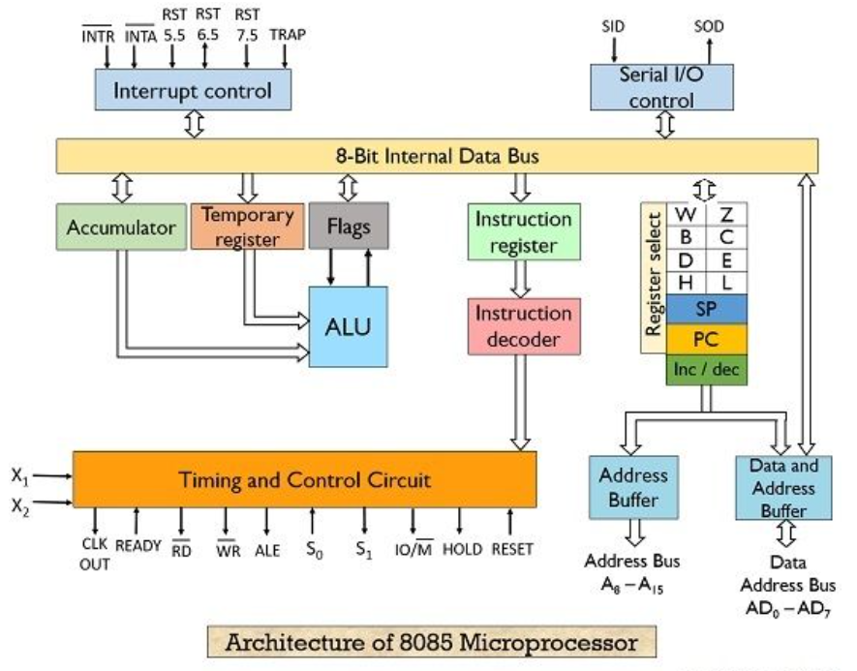

## **Timing and Control Unit**

**The timing and control unit** is the section of the CPU.

* It is used to generate timing and control signals which are necessary for the execution of instructions.
* It is used to control data flow between CPU and peripherals (including memory).
* It is used to provide status, control and timing signals which are required for the operation of memory and I/O devices.
* It is used to control the entire operations of the microprocessor and peripherals connected to it.

Thus we can see that the control unit of the CPU acts as the brain of the computer system.

## **Registers**

**Registers** are used for temporary storage and manipulation of data and instructions by the microprocessor. Data remain in the registers till they are sent to the I/O devices or memory. Intel 8085 microprocessor has the following registers:

* One 8-bit accumulator (ACC) i.e. register A
* Six general purpose registers of 8-bit, these are B,C, D, E, H and L
* One 16-bit stack pointer, SP
* One 16-bit Program Counter, PC
* Instruction register
* Temporary register

In addition to the above mentioned registers the 8085 microprocessor contains a set of five flip-flops which serve as flags (or status flags).

A flag is a flip-flop which indicates some conditions which arises after the execution of an arithmetic or logical instruction.

1. **Accumulator (ACC):** The accumulator is an 8-bit register associated with the ALU. The register 'A' is an accumulator in the 8085. It is used to hold one of the operands of an arithmetic and logical operation.  
   The final result of an arithmetic or logical operation is also placed in the accumulator.
2. **General-Purpose Registers:** The 8085 microprocessor contains six 8-bit general purpose registers. They are: B, D, C, E, H and L register.  
   To hold data of 16-bit a combination of two 8-bit registers can be employed.  
   The combination of two 8-bit registers is called **register pair**. The valid register pairs in the 8085 are: D-E, B-C and H-L. The H-L pair is used to act as a memory pointer.
3. **Program Counter (PC):** It is a 16-bit special purpose register. It is used to hold the address of memory of the next instruction to be executed. It keeps the track of the instruction in a program while they are being executed.  
   The microprocessor increments the content of the next program counter during the execution of an instruction so that at the end of the execution of an instruction it points to the next instruction?s address in the program.
4. **Stack Pointer (SP):** It is a 16-bit special function register used as memory pointer. A stack is nothing but a portion of RAM. In the stack, the contents of only those registers are saved, which are needed in the later part of the program.  
   The stack pointer (SP) controls the addressing of the stack. The Stack Pointer contains the address of the top element of data stored in the stack.
5. **Instruction Register:** The instruction register holds the opcode (operation code or instruction code) of the instruction which is being decoded and executed.
6. **Temporary Register:** It is an 8-bit register associated with the ALU. It holds data during an arithmetic/logical operation. It is used by the microprocessor. It is not accessible to programmer.
7. **Flags:** The Intel 8085 microprocessor contains five flip-flops to serve as a status flags. The flip-flops are reset or set according to the conditions which arise during an arithmetic or logical operation.

**The five status flags of Intel 8085 are:**

* Carry Flag (CS)
* Parity Flag (P)
* Auxiliary Carry Flag (AC)
* Zero Flag(Z)
* Sign Flag(S)

If a flip-flop for a particular flag is set, then it indicates 1. When it is reset, it indicates 0.

**Data and Address Bus**

* The Intel 8085 is an 8-bit microprocessor. Its **data bus** is 8-bit wide and therefore, 8 bits of data can be transmitted in parallel from or to the microprocessor.
* The Intel 8085 requires an **address bus** of 16-bit wide as the memory addresses are of 16-bits.
* The 8 most significant bits of the address are transmitted by the address bus, A-bus (pins A8 ? A15).
* The 8 least significant bits of the address are transmitted by data/address bus, AD-bus (pins AD0 ? AD7).

## **Pin Configuration**

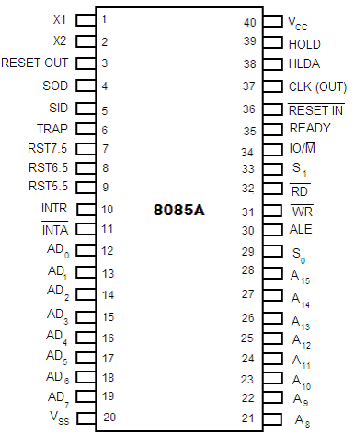

**Fig no.1.1: Pin diagram of Intel 8085 microprocessor**

The descriptions of various pins are as follows:

**Address Bus and Data Bus**

* **A8 -A15 (Output):** These are **address bus** and are used for the most significant bits of the memory address or 8-bits of I/O address.
* **AD0 -AD7 (Input/output):** These are time multiplexed **address/data bus** i.e. they serve dual purpose. They are used for the least significant 8 bits of the memory address or I/O address during the first cycle. Again they are used for data during 2nd and 3rd clock cycles.

**Control and Status Signals**

* **ALE (Output):** ALE stands for **Address Latch Enable** signal. ALE goes high during first clock cycle of a machine cycle and enables the lower 8-bits of the address to be latched either into the memory or external latch.
* **IO/M (Output):** It is a **status signal** which distinguishes whether the address is for memory or I/O device.
* **S0, S1 (Output):** These are **status signals** sent by the microprocessors to distinguish the various types of operation given in table below:

|  |  |  |
| --- | --- | --- |
| **S1** | **S0** | **Operations** |
| 0 | 0 | HALT |
| 0 | 1 | WRITE |
| 1 | 0 | READ |
| 1 | 1 | FETCH |

**Status codes for Intel 8085**

* **RD (Output):** RD is a **signal to control READ operation**. When it goes low, the selected I/O device or memory is read.
* **WR (Output):** WR is a **signal to control WRITE operation**. When it goes low, the data bus' data is written into the selected memory or I/O location.
* **READY (Input):** It is used by the microprocessor to sense whether a peripheral is ready to transfer a data or not. If READY is high, the peripheral is ready. If it is low the micro processor waits till it goes high.

**Interrupts and Externally Initiated Signals**

* **HOLD (INPUT):** HOLD indicates that another device is requesting for the use of the address and data bus.
* **HLDA (OUTPUT):** HLDA is a signal for **HOLD acknowledgement** which indicates that the HOLD request has been received. After the removal of this request the HLDA goes low.
* **INTR (Input):** INTR is an **Interrupt Request Signal**. Among interrupts it has the lowest priority. The INTR is enabled or disabled by software.
* **INTA (Output):** INTA is an **interrupt acknowledgement** sent by the microprocessor after INTR is received.
* **RST 5.5, 6.5, 7.5 and TRAP (Inputs):** These **all are interrupts**. When any interrupt is recognized the next instruction is executed from a fixed location in the memory as given below

**Reset Signals**

* **RESET IN (Input):** It resets the program counter (PC) to 0. It also resets interrupt enable and HLDA flip-flops. The CPU is held in reset condition till RESET is not applied.
* **RESET OUT (Output):** RESET OUT indicates that the CPU is being reset.

**Clock Signals**

* **X1, X2 (Input):** X1 and X2 are terminals to be connected to an external crystal oscillator which drives an internal circuitry of the microprocessor. It is used to produce a suitable clock for the operation of microprocessor.
* **CLK (Output):** CLK is a **clock output** for user, which can be used for other digital ICs. Its frequency is same at which processor operates.

**Serial I/O Signals**

* **SID (Input):** SID is data line for **serial input**. The data on this line is loaded into the seventh bit of the accumulator when RIM instruction is executed.
* **SOD (Output):** SOD is a data line for **serial output**. The seventh bit of the accumulator is output on SOD line when SIM instruction is executed.

**PROCEDURE :**

1. Open https://www.sim8085.com website .

2. Write your program inside the “main.asm” box .

3. Enter the inputs in the respective memory location .

4. Click on “Assemble and Load Program” .

5. After successful compilation click on “Run one instruction” .

6. Click on it till you reach “HLT” in your program .

7. Click on “Stop program and return to editing”.

**RESULT & OBSERVATION :**

* 1. Program to add two numbers :

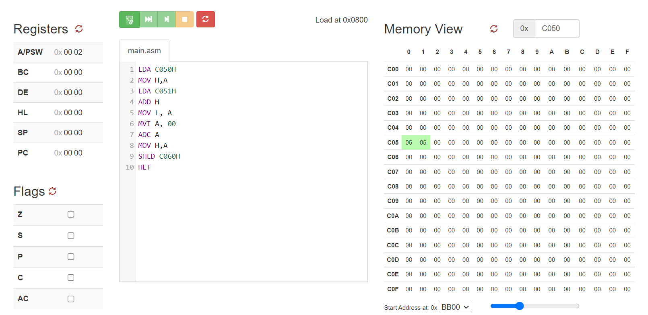

Before execution of problem 1

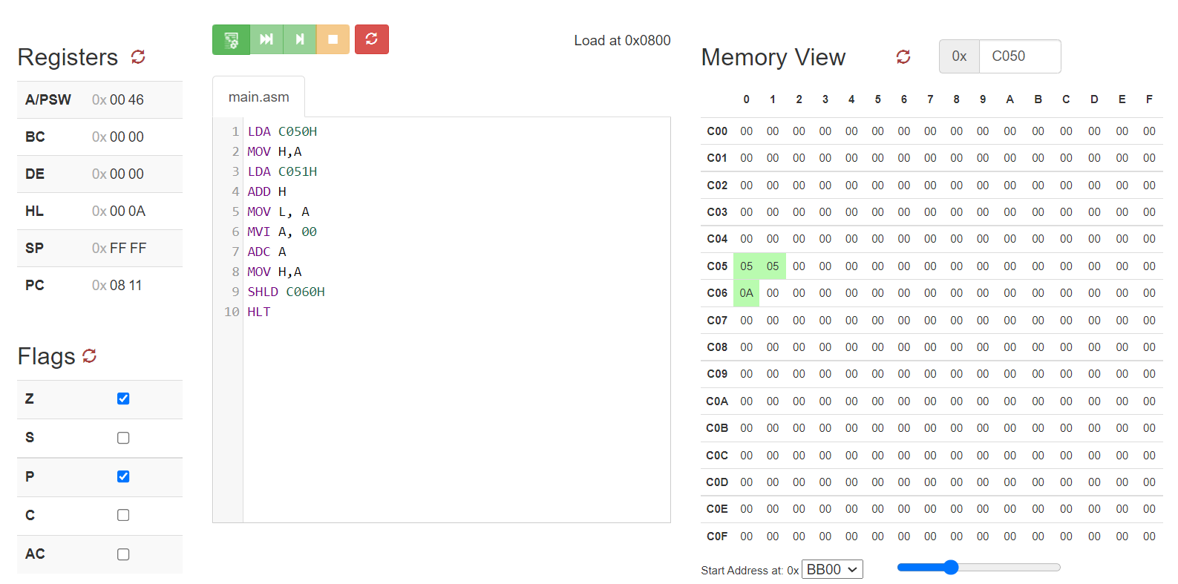

After execution of problem 1

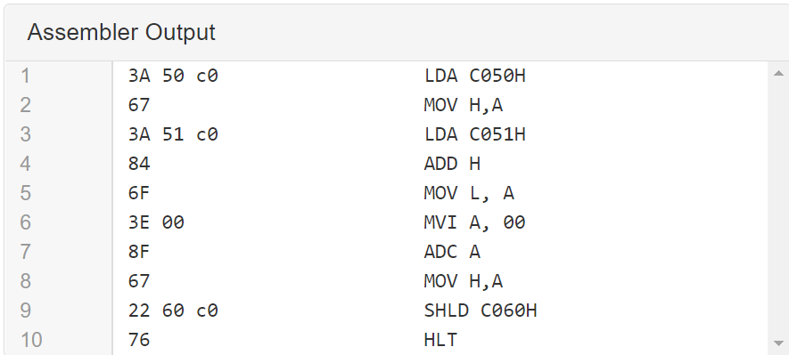

Assembler output of problem 1

Input

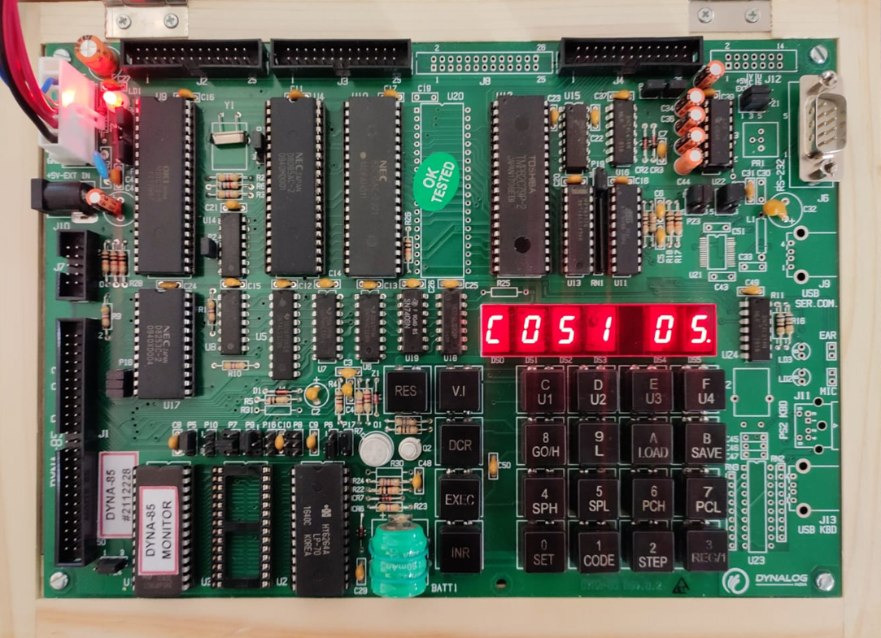

First number 5 stored at C051

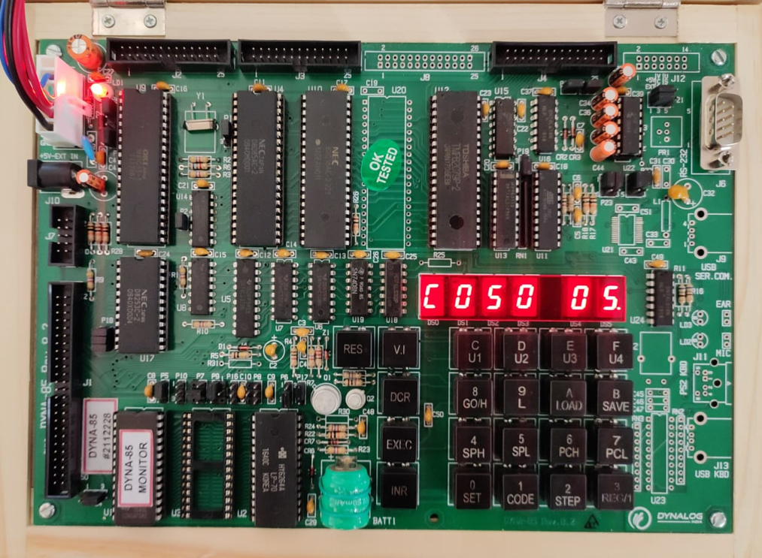

Second number 5 stored at C050

Output

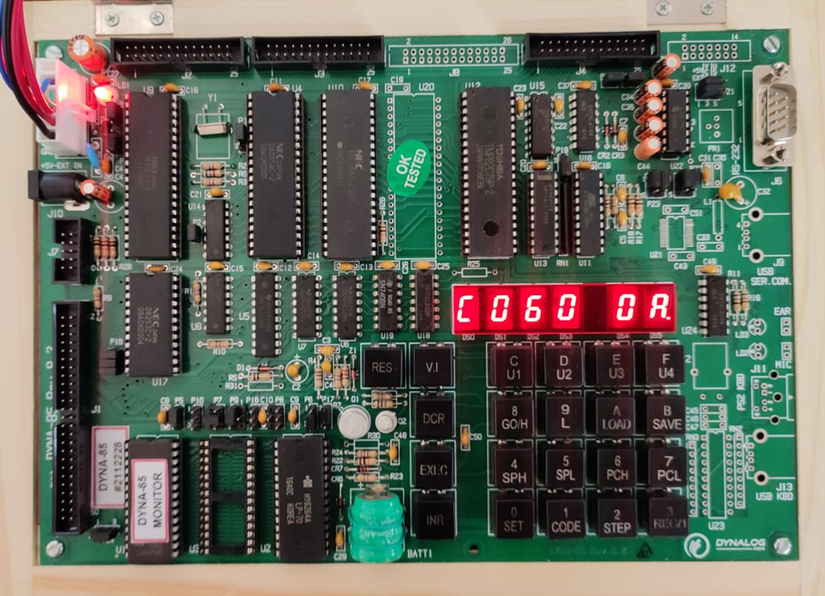

Result 10 or in hexadecimal A is displayed

2. Program to COPY and PASTE Block of data from source memory address to destination address :

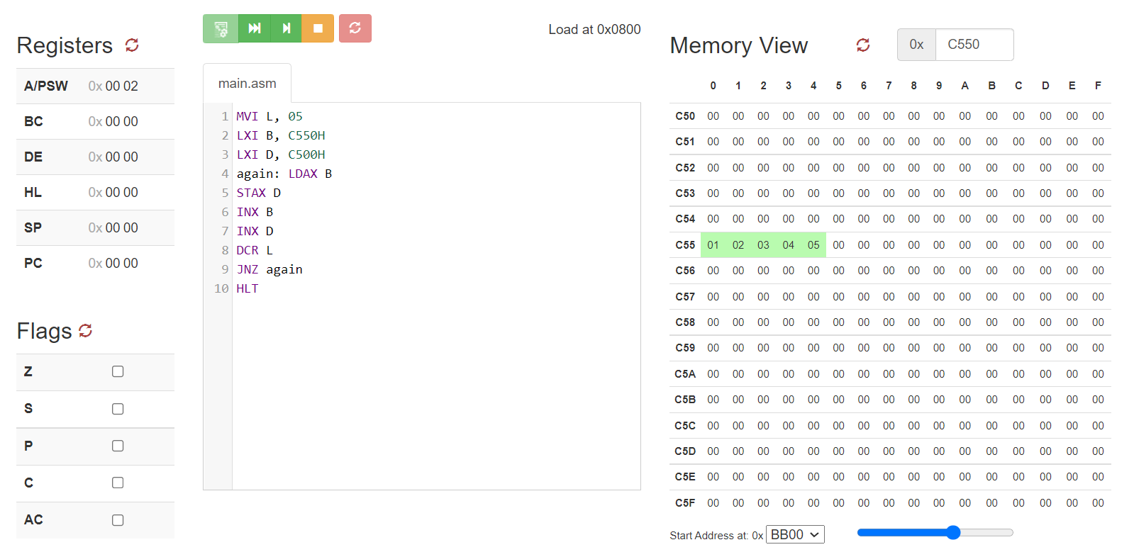

Before execution of problem 2

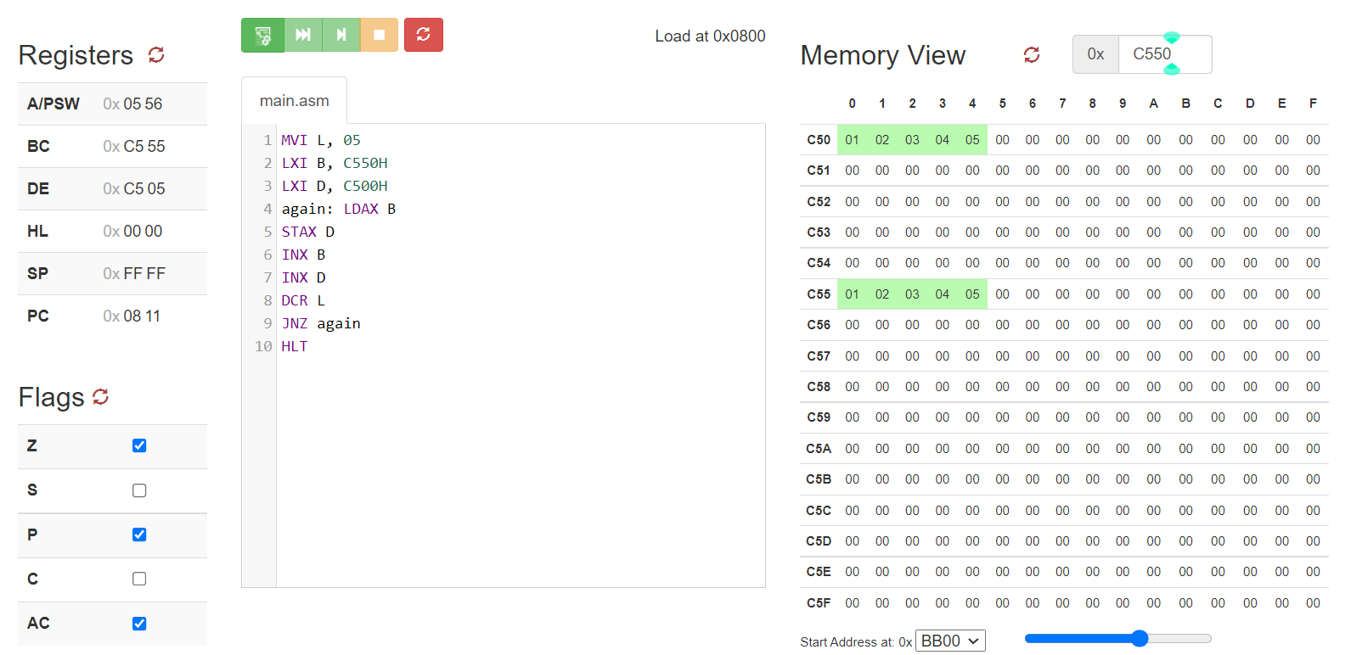

After execution of problem 2

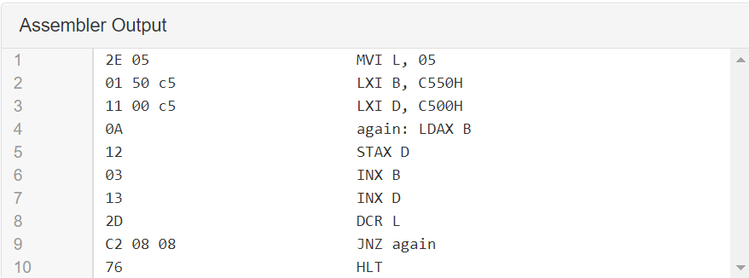

Input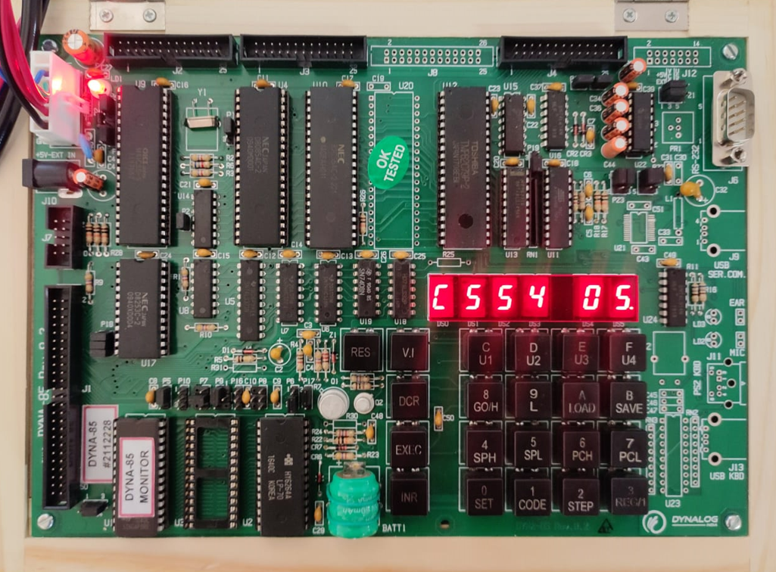

5 written at location C554

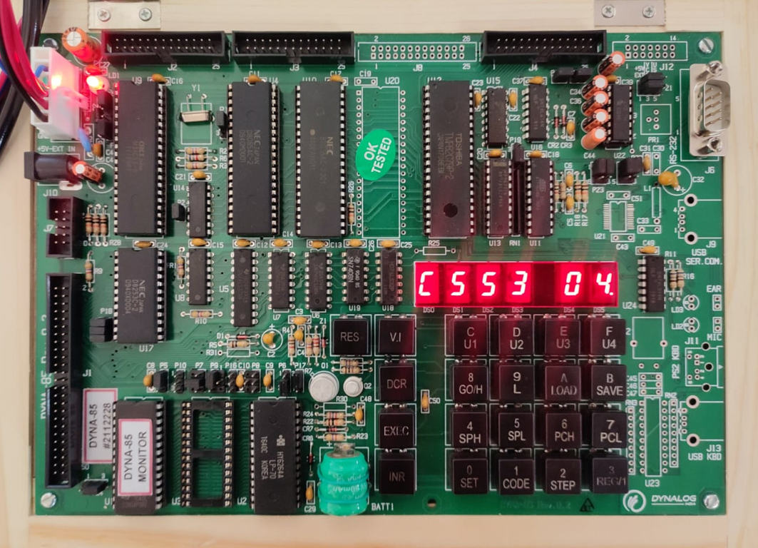

4 written at location C553

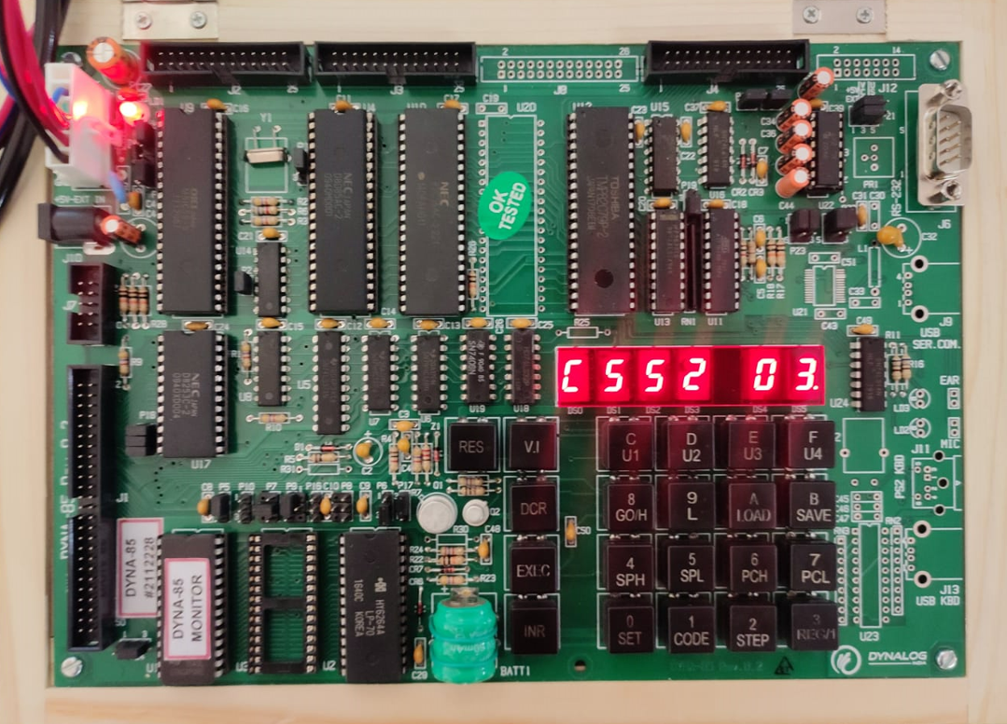

3 written at location C552

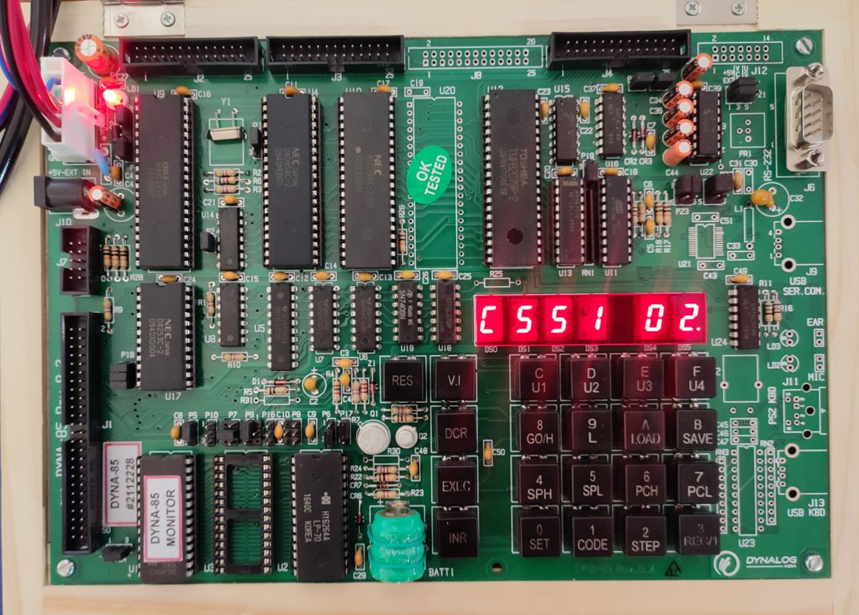

2 written at location C551

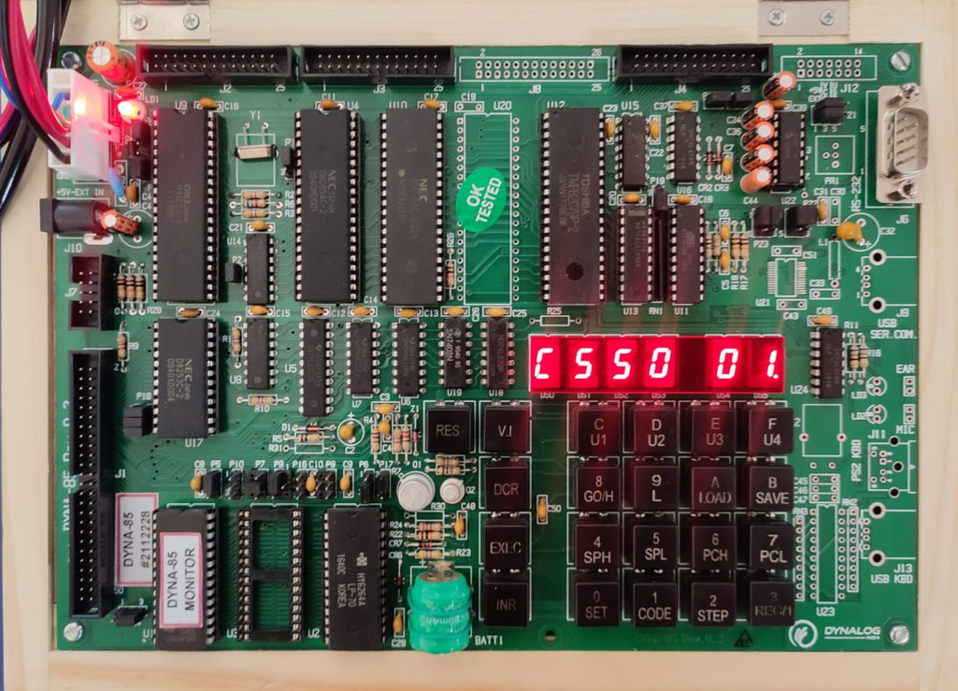

1 written at location C550

Output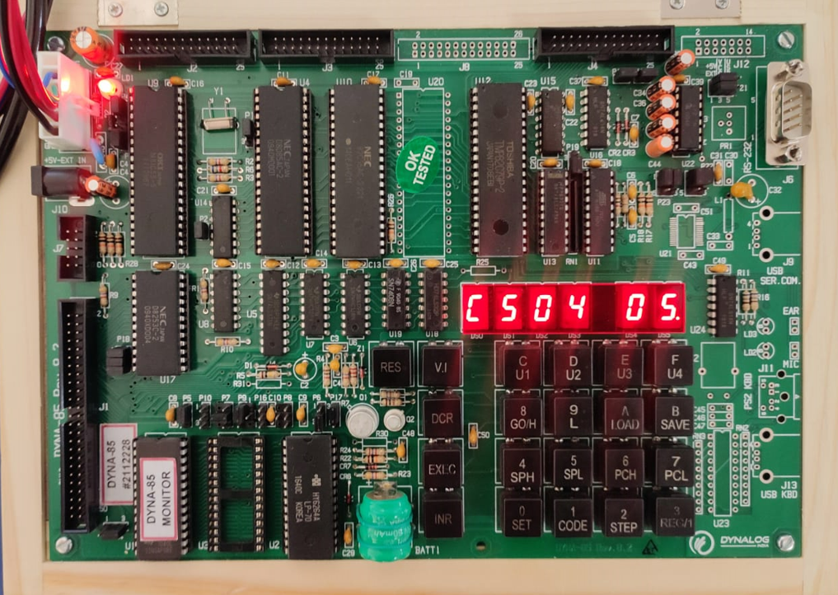

5 copied at location C504

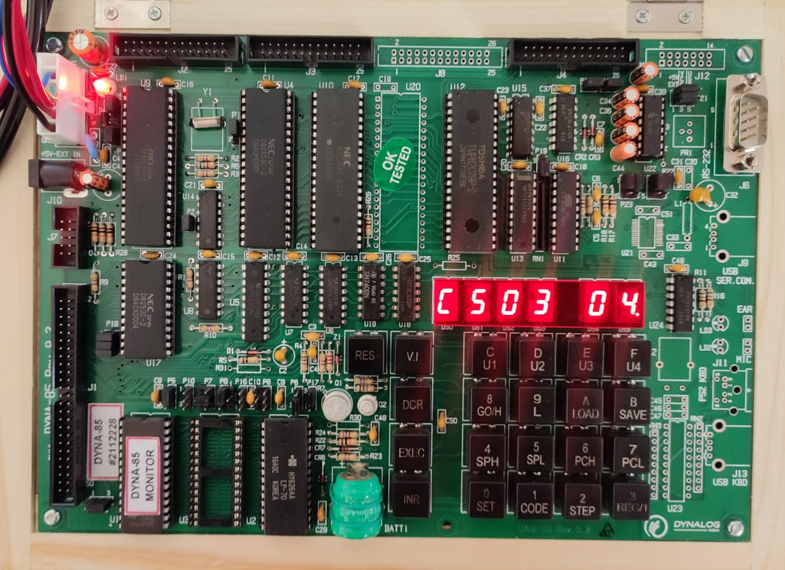

4 copied at location C503

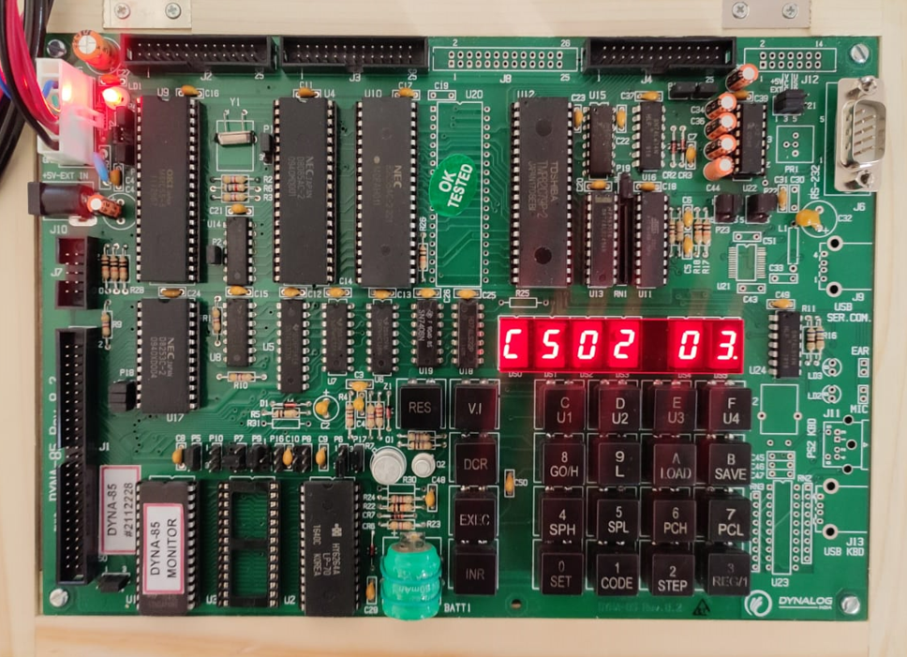

3 copied at location C502

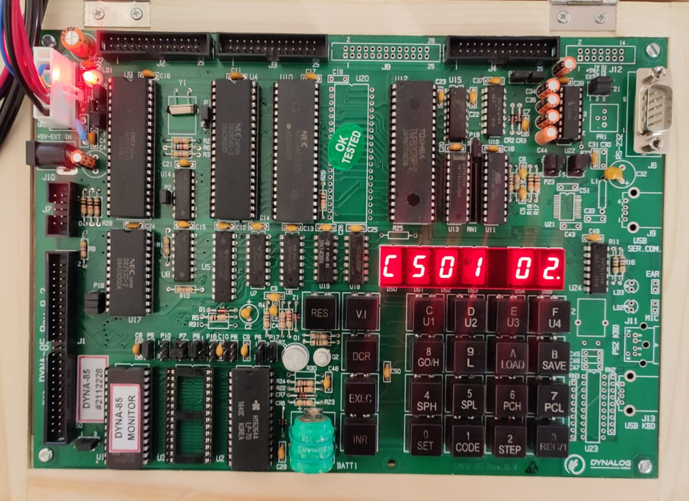

2 copied at location C501

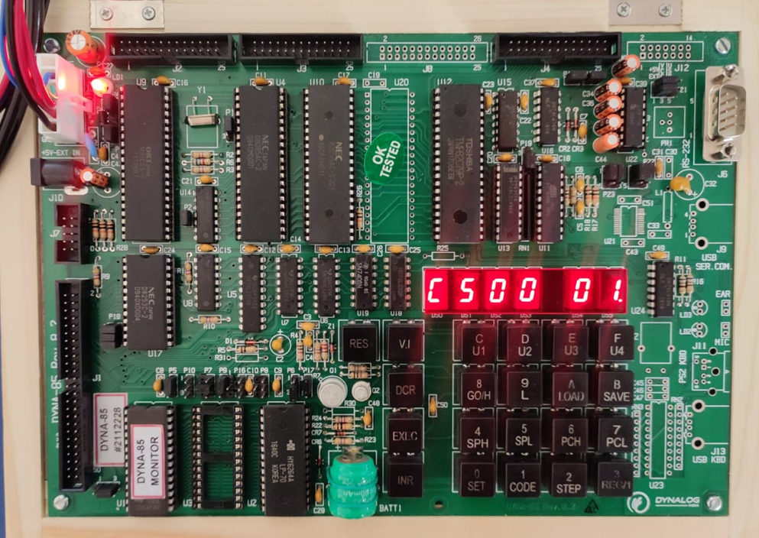

1 copied at location C500

**CONCLUSION :**

